Dear #PARENTNAME#,
This year our school has started using Carrot Rewards as a great way of managing behaviour, motivating pupils and encouraging engagement.
We will be awarding students for key skills and achievements allowing us to build a picture of how they are developing both academically and within the classroom environment.
We know a really important part of this process is to make sure parents are involved as much as possible and would love to share this information with you.
The good news is it is really simple for you to get involved using a free mobile app, as well as being able to access from any computer or tablet.
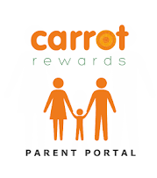
Simply download the Carrot Rewards Parent Portal app found in the Android and iOS App Store.

Sign up to the parent portal using your Childs www.MyStickers.co.uk login found below.
https://www.carrotrewards.co.uk/parent-portal/signup or Scan ME
Childs MyStickers.co.uk Username | Password
#USERNAME# | #PASSWORD#

